**Data Structures and Algorithms**



Session: 2022 – 2026

**Submitted by:**

Muhammad Saad Akmal        2022-CS-148

**Submitted To:**

Mr. Muhammad Faraz

Department of Computer Science

**University of Engineering and Technology**

**Lahore Pakistan**

# **Heap Sort:**

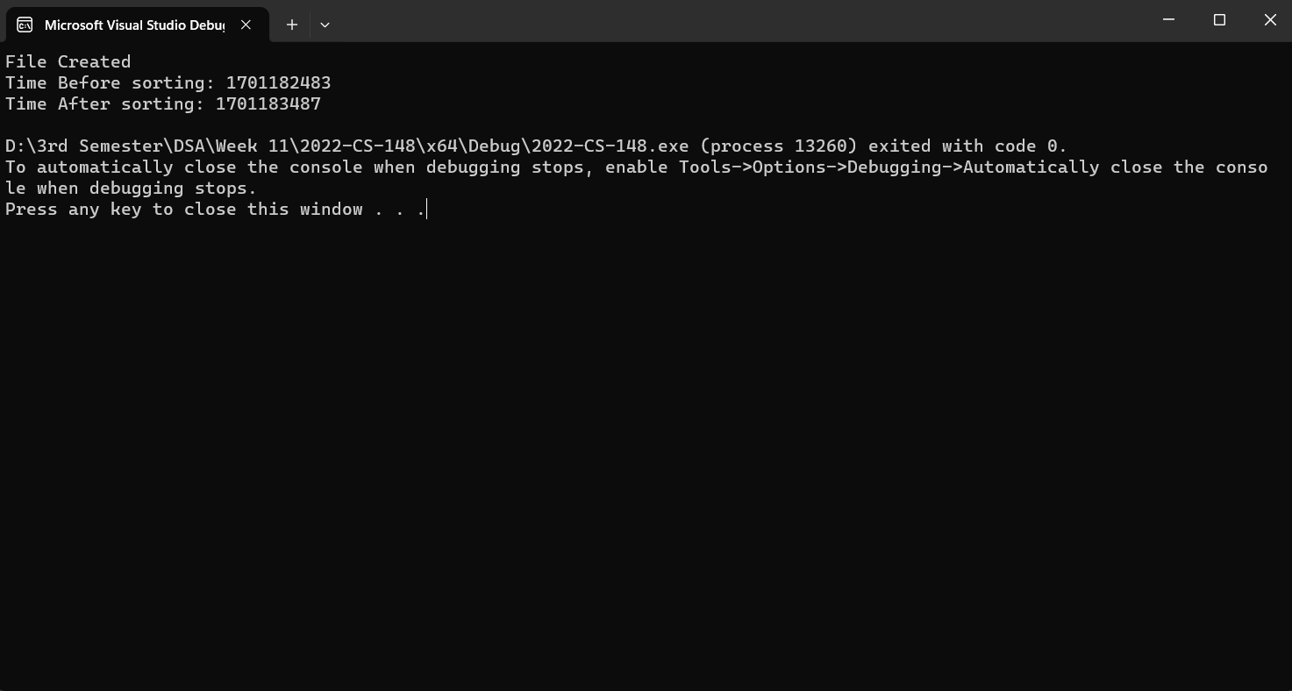Time taken to sort 1GB file = 17 minutes

# **Bubble Sort:**

Time taken to sort 1MB file = 87 minutes

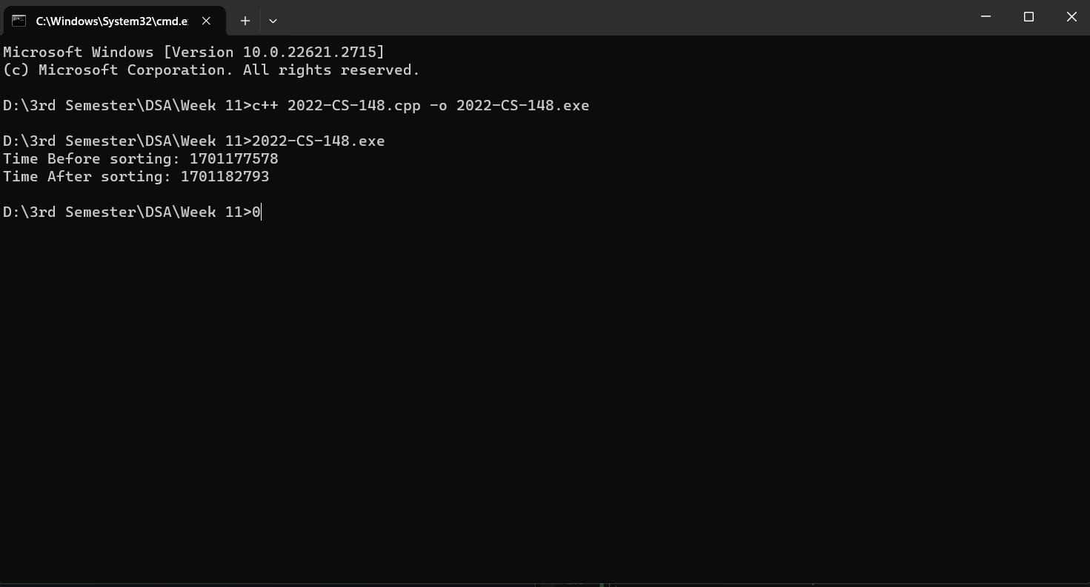

# **Selection Sort:**

Time taken to sort 1MB file = 76 minutes

